**Data Structure**

**&**

**Algorithm**

**Class IX**

**Lab 11**

|  |
| --- |
| Lab Objectives:SortingStable and Non Stable SortingAdaptive and non adaptive sorting |

# Sorting Techniques

Sorting refers to arranging data in a particular format. Sorting algorithm specifies the way to arrange data in a particular order. Most common orders are in numerical or lexicographical order.

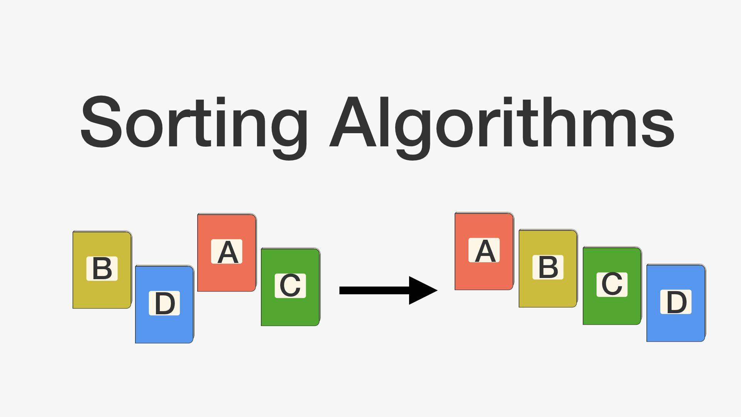

## The importance of sorting lies in the fact that data searching can be optimized to a very high level, if data is stored in a sorted manner.

## Following are some of the examples of sorting in real-life scenarios −

## **IMG_256*Telephone Directory*** − The telephone directory stores the telephone numbers of people sorted by their names, so that the names can be searched easily.

## ***Dictionary*** − The dictionary stores words in an alphabetical order so that searching of any word becomes easy.



# In-place Sorting and Not-in-place Sorting

## IMG_256Sorting algorithms may require some extra space for comparison and temporary storage of few data elements. These algorithms do not require any extra space and sorting is said to happen in-place, or for example, within the array itself. This is called in-place sorting. **Bubble sort** is an example of in-place sorting.

## However, in some sorting algorithms, the program requires space which is more than or equal to the elements being sorted. Sorting which uses equal or more space is called not-in-place sorting. **Merge-sort** is an example of not-in-place sorting.

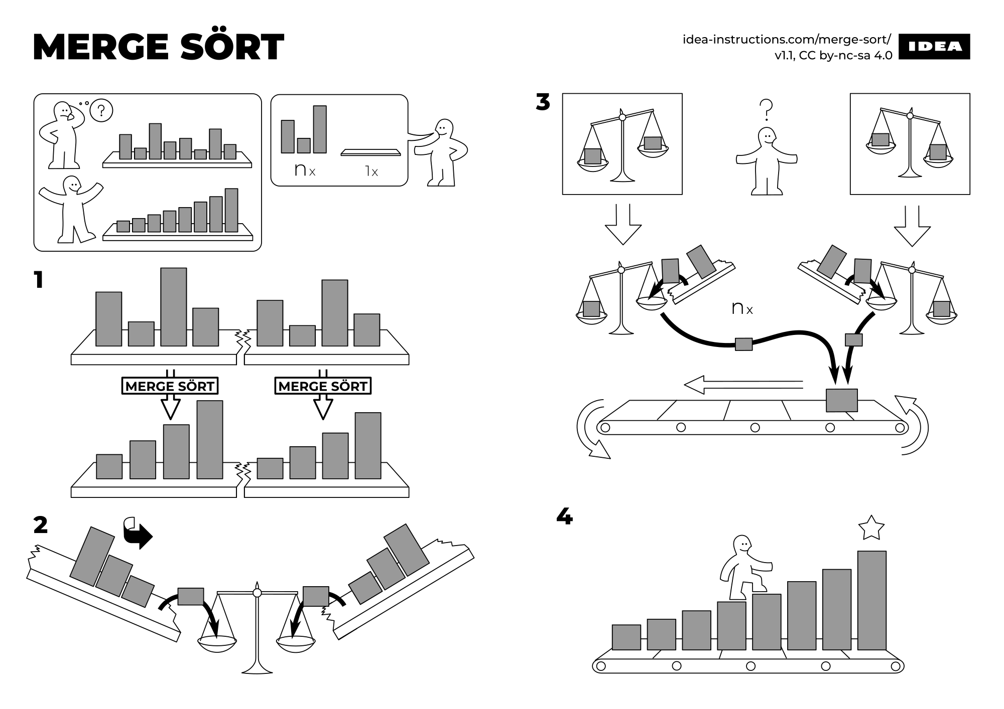

## Bubble sort and Merge sort will be discussed later in briefly.

# Stable and Not Stable Sorting

## IMG_256If a sorting algorithm, after sorting the contents, does not change the sequence of similar content in which they appear, it is called stable sorting.

## IMG_256If a sorting algorithm, after sorting the contents, changes the sequence of similar content in which they appear, it is called unstable sorting.

# Adaptive and Non-Adaptive Sorting Algorithm

## A sorting algorithm is said to be adaptive, if it takes advantage of already 'sorted' elements in the list that is to be sorted. That is, while sorting if the source list has some element already sorted, adaptive algorithms will take this into account and will try not to re-order them.

## A non-adaptive algorithm is one which does not take into account the elements which are already sorted. They try to force every single element to be re-ordered to confirm their sortedness.

# Important Terms

## Some terms are generally coined while discussing sorting techniques, here is a brief introduction to them −

## **Increasing Order**

## A sequence of values is said to be in increasing order, if the successive element is greater than the previous one. For example, 1, 3, 4, 6, 8, 9 are in increasing order, as every next element is greater than the previous element.

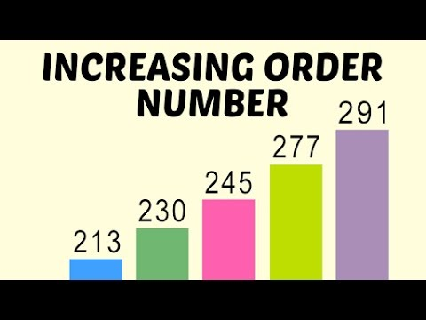

## **Decreasing Order**

## A sequence of values is said to be in decreasing order, if the successive element is less than the current one. For example, 9, 8, 6, 4, 3, 1 are in decreasing order, as every next element is less than the previous element.

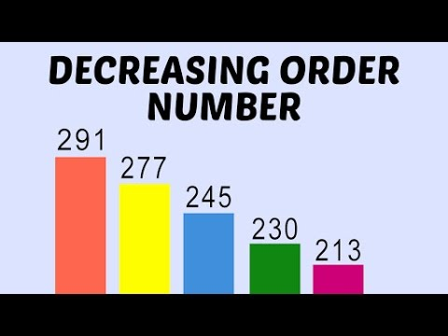

## **Non-Increasing Order**

## A sequence of values is said to be in non-increasing order, if the successive element is less than or equal to its previous element in the sequence. This order occurs when the sequence contains duplicate values. For example, 9, 8, 6, 3, 3, 1 are in non-increasing order, as every next element is less than or equal to (in case of 3) but not greater than any previous element.

## **Non-Decreasing Order**

## A sequence of values is said to be in non-decreasing order, if the successive element is greater than or equal to its previous element in the sequence. This order occurs when the sequence contains duplicate values. For example, 1, 3, 3, 6, 8, 9 are in non-decreasing order, as every next element is greater than or equal to (in case of 3) but not less than the previous one.